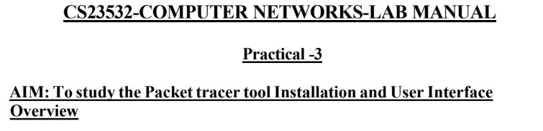

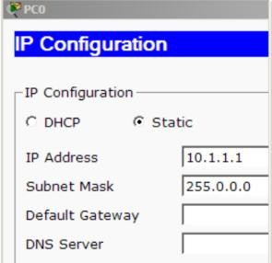

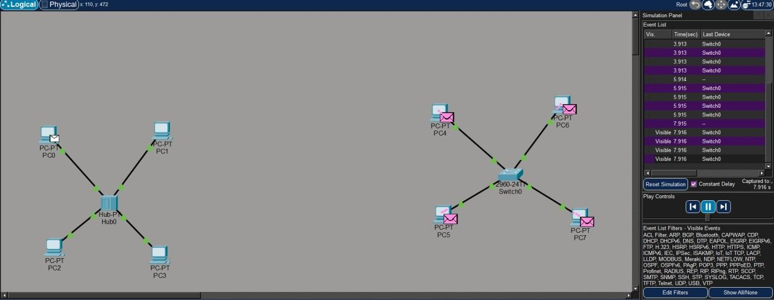
Result:
Thus the cisco packet tracer app is explored and simulations are done for hub and switch

